# **Name: Abdurrahman Qureshi**

# **Roll No: 210451**

Practical No: 1

**1)Installation of Visual Studio**

**CODE:**

**Step 1.** For downloading the [Visual Studio IDE](https://www.javatpoint.com/install-visual-studio), go through the link given below:

<https://www.visualstudio.com/downloads>

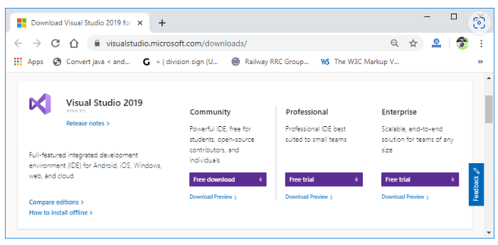

**Step 2.** As clicked on download link, it starts downloading an .exe file, as shown in the image below.

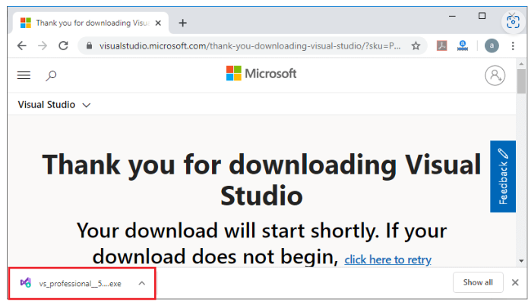

**Step 3.** Click on the .exe file and then, it shows a pop-up window.

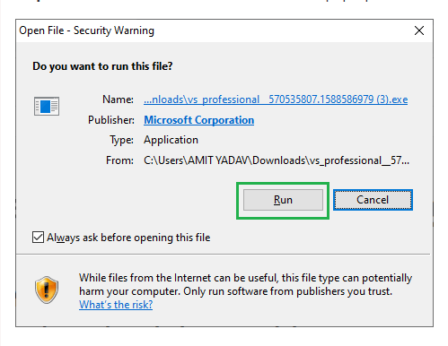

**Step 4.** Click on the **Run** button, and then it shows the below image.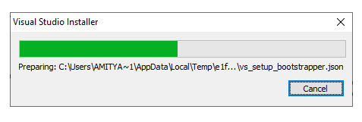

**Step 5.** Click on the **Continue** Button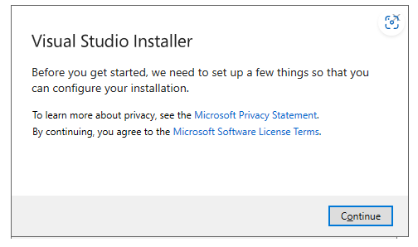

**Step 6.** After clicking on Continue, Visual Studio will start downloading its initial files as shown in the image below.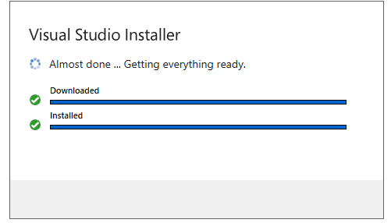

**Step 7.** It shows the screen below, in which you have to click on the install button as shown. 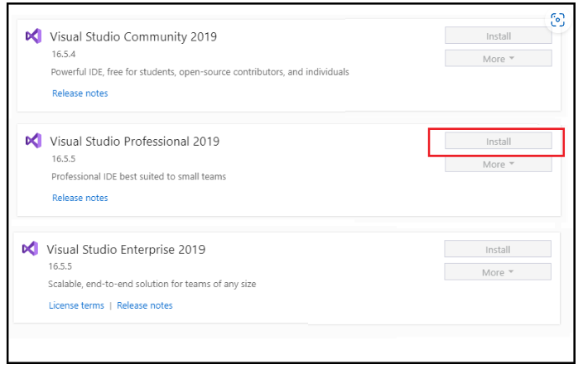

**Step 8.** After clicking on install button, your Visual Studio IDE will start downloading and then it displays the screen, as we have shown below. 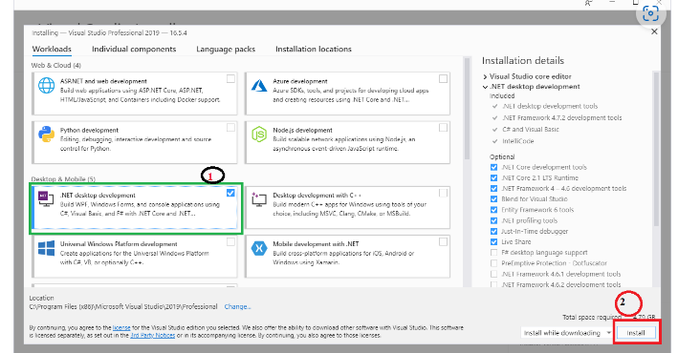

**Step 9.** From the above image, select **.NET desktop development** and click on install open which may take some time to download the Visual Studio in your system, as shown in below image.

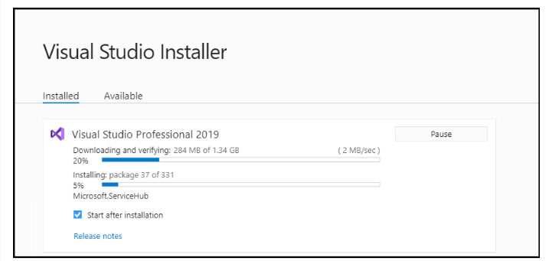

**Step 10.** After successfully downloading and installing the Visual Studio' supportive file, it shows the below screen in your system.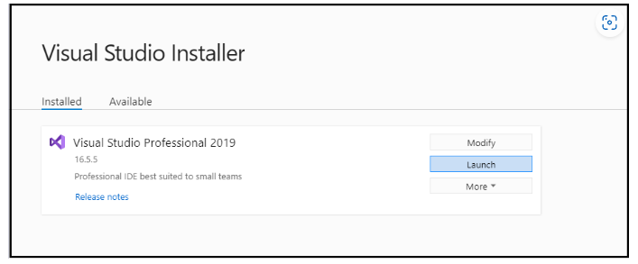

**Step 11.** Click on Launch button, and then it shows the below image in your screen that represents Visual Studio has been successfully launched in your machine.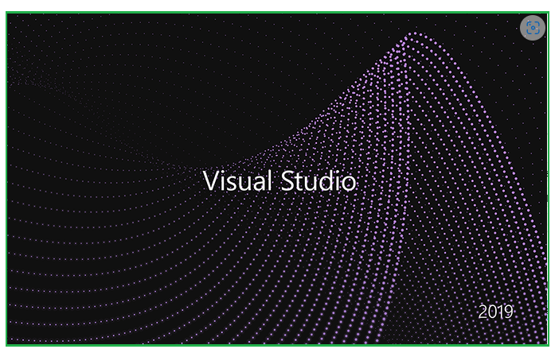

And then it shows a below screen to select the Visual Studio theme. By default, it takes Blue theme, and if you want to change, you can easily change the Visual Studio theme by clicking on other themes.

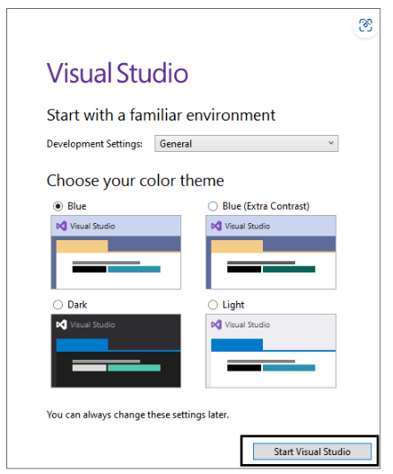

**Step 12.** After selecting the Theme, click on **Start Visual Studio** and then it shows a below image in your system screen for creating a new project. 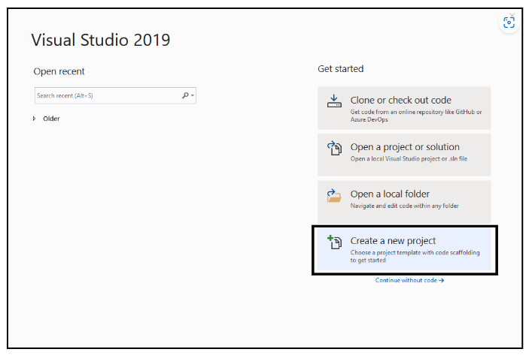

**Step 13.** After click on **Create a new project**, it shows the below screen to choose what type of application you are going to build in Visual studio. In this you can select the Console based application or Window Form Based application, as shown in below image. Here we chose the Console based application, and then click on the **Next** button. 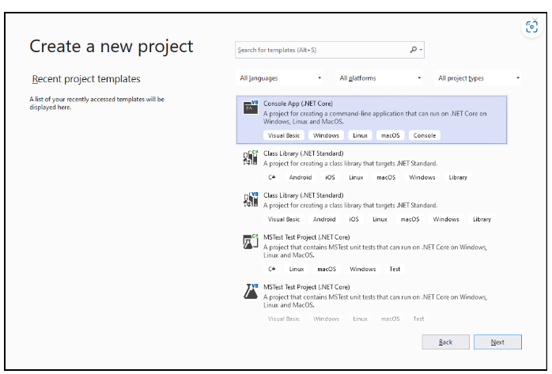

**Step 14.** When you click the **Next** button, it shows the below image to define the project name, and also reminds if you want to place the solution and project in the same directory.

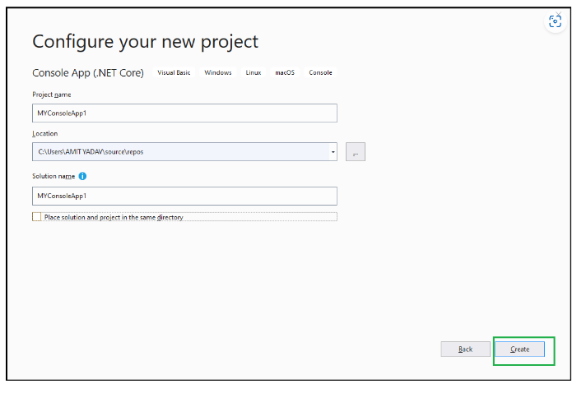

**Step 15.** And finally, your new project will be successfully created.